Scordelis-Lo Roof Validation in Kratos with IGA element

Objective:
Validate the Scordelis-Lo Roof with Kratos IGA Shell3pElement for linear analysis for both strong and weak BC and perform a convergence study.
Validation is performed against Josef M. Kiendl's Dissertation – Benchmark 6.2.1

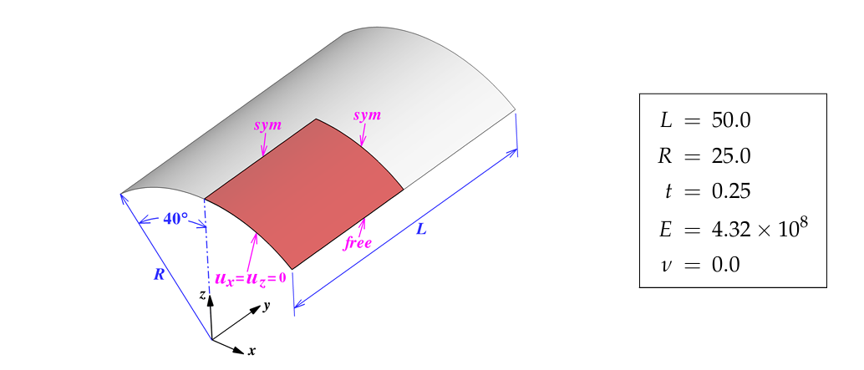
- Model Description:
Fig.1: Scordelis-Lo Roof - Taken from Josef M. Kiendl's Dissertation

- Results:

Maximum displacement, ie, Displacement Z at the middle of the roof, is taken for the convergence study. For both strong and weak BC, the convergence was achieved. Tables 1,2, and 3 show convergence behaviour for different polynomial degrees. Figure 1 shows the convergence plot

Control Point Refinement | Number of Control Points | Displacement Z
5 | 8 | -0.16537
8 | 11 | -0.25836
10 | 13 | -0.28012
20 | 23 | -0.29888
40 | 43 | -0.30044
Table 1: Convergence study with polynomial degree 2

Control Point Refinement | Number of Control Points | Displacement Z
5 | 9 | -0.297
8 | 12 | -0.30031
Table 2: Convergence study with polynomial degree 3

Control Point Refinement | Number of Control Points | Displacement Z
0 | 5 | -0.2593
2 | 7 | -0.294
5 | 10 | -0.3007
Table 3: Convergence study with polynomial degree 4

Figure 1: Combined Convergence Plot

